Assignment 3 - 320: Digital Therapy Assistant Deployment Summary

Author
Name: Tyler Stier
Group Members: Greyson Chavez, David Gonzalez
Email: tstier@chapman.edu
Date: May 13, 2026

Diagrams

Context Diagram
Show Digital Therapy Assistant in context with users (Patients, Therapists, Administrators) and external systems (LLM Provider, Email Service, EHR Systems)
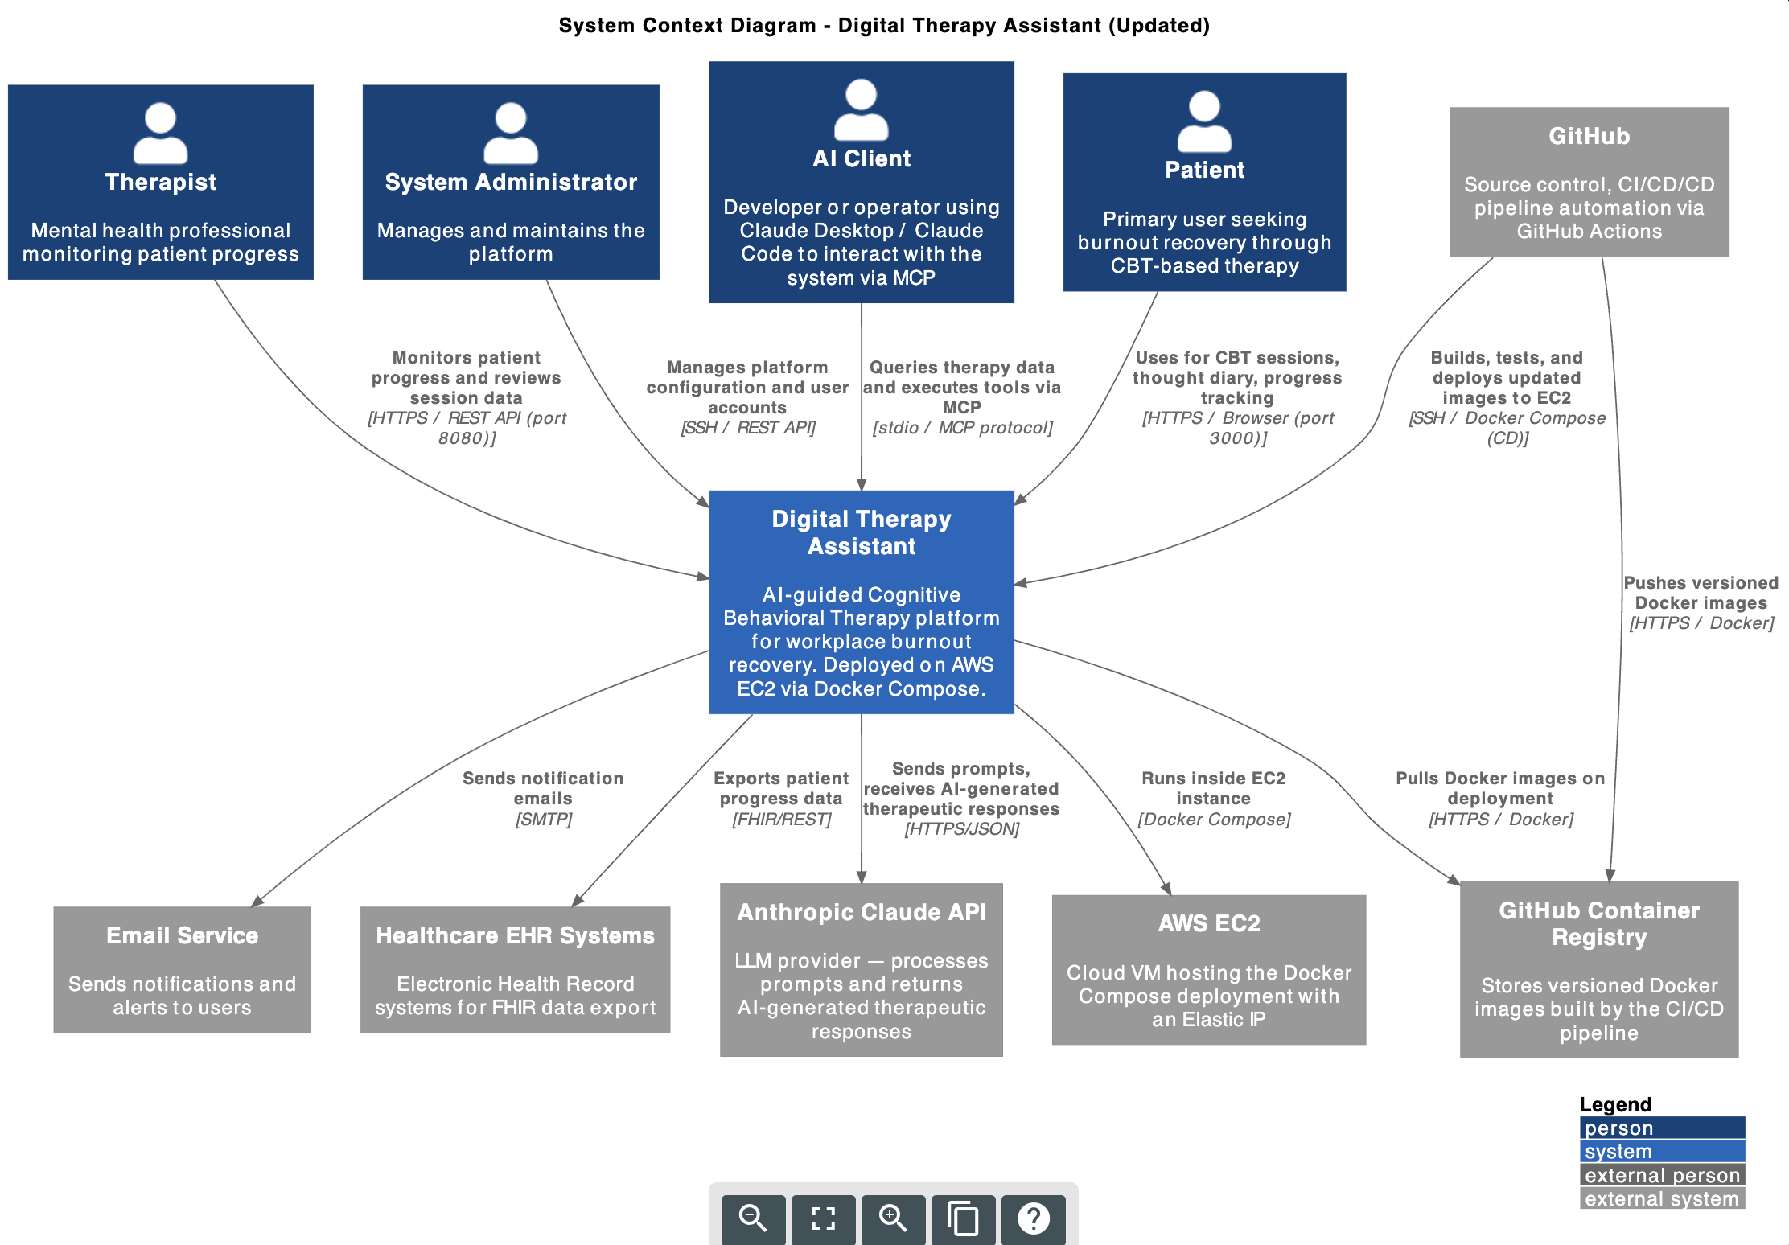

Container Diagram
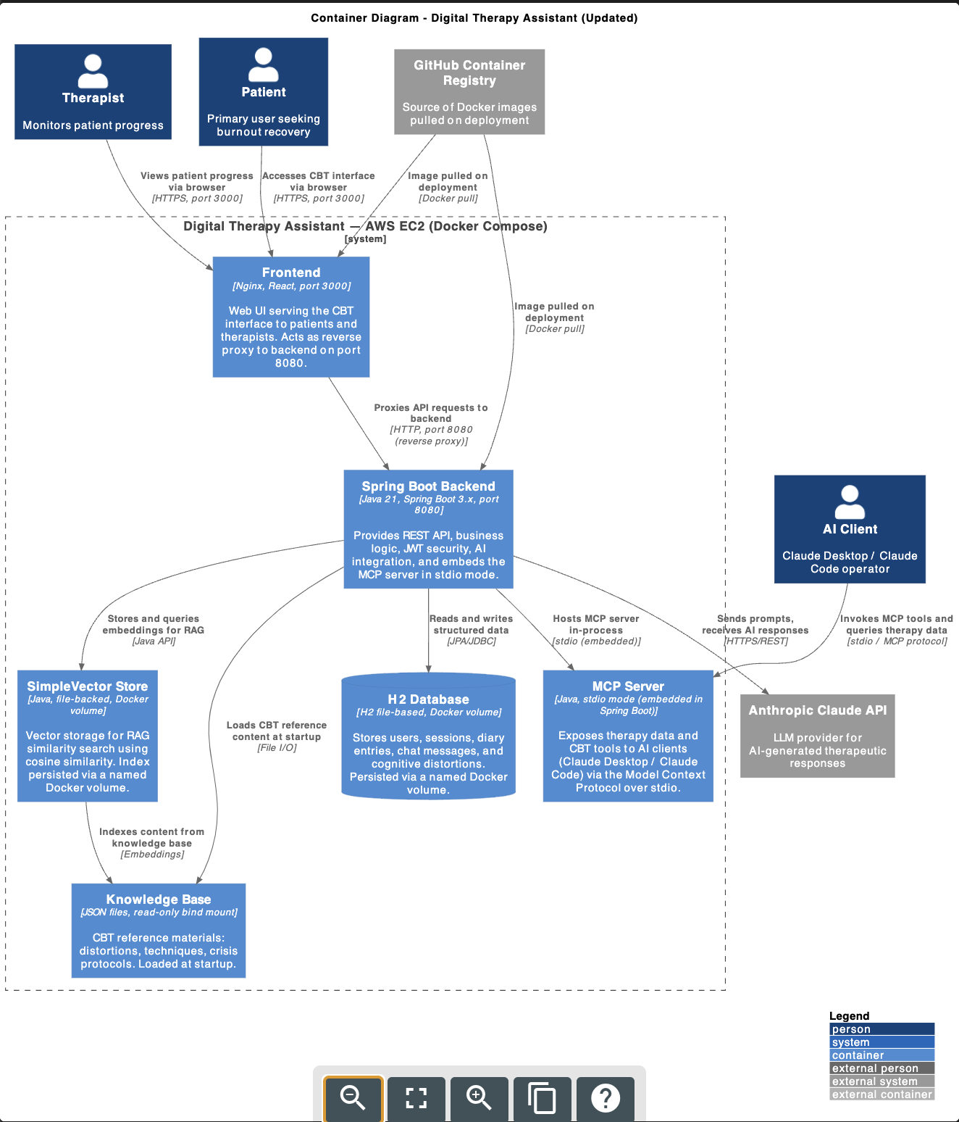

Component Diagram
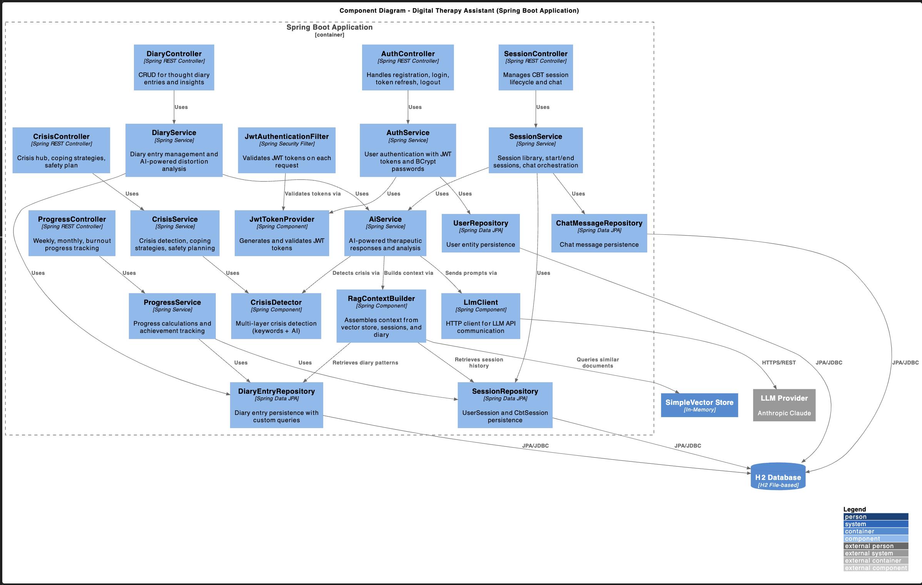

Class Diagram
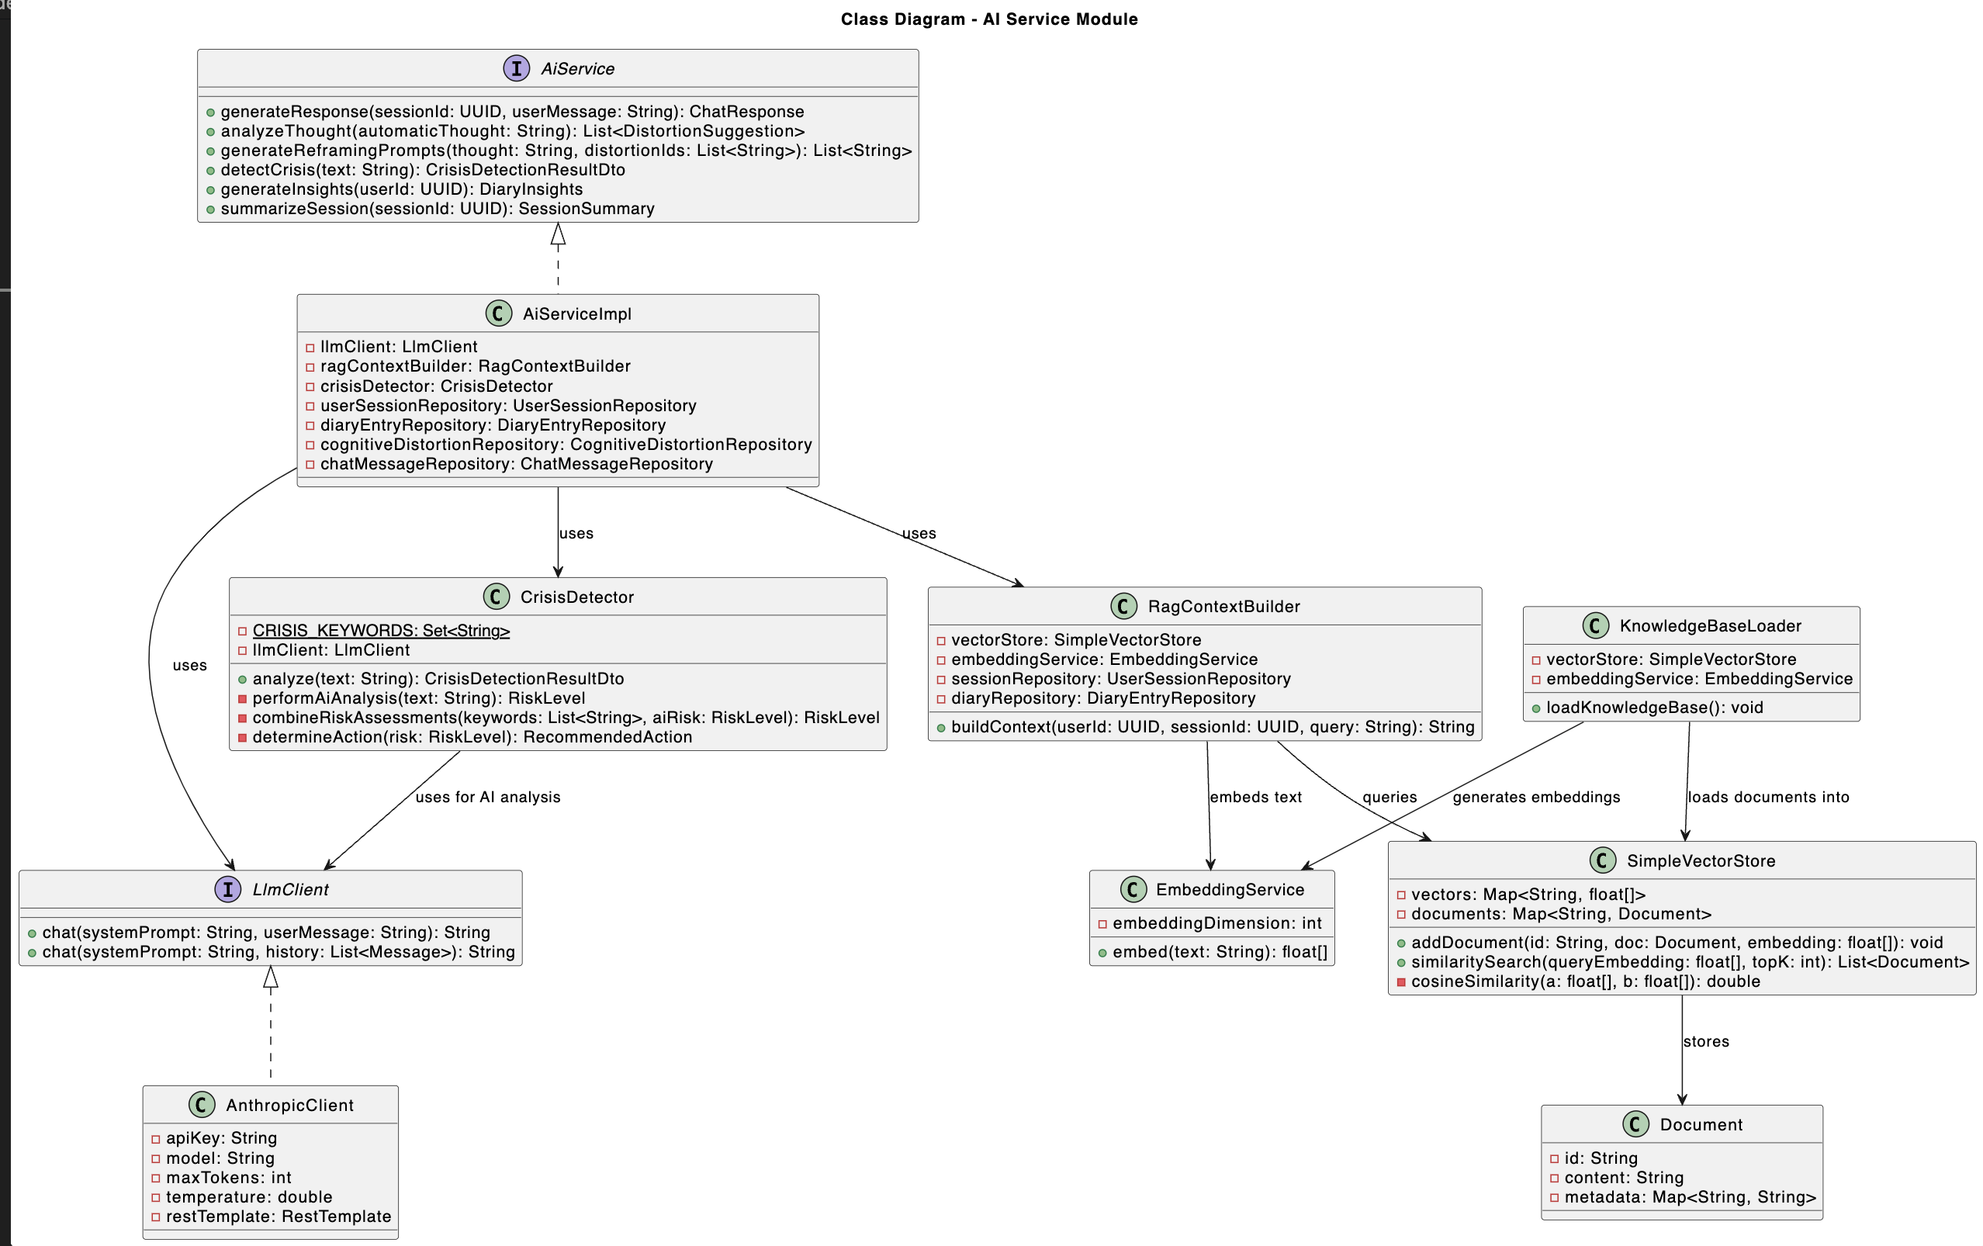

Sequence Diagram
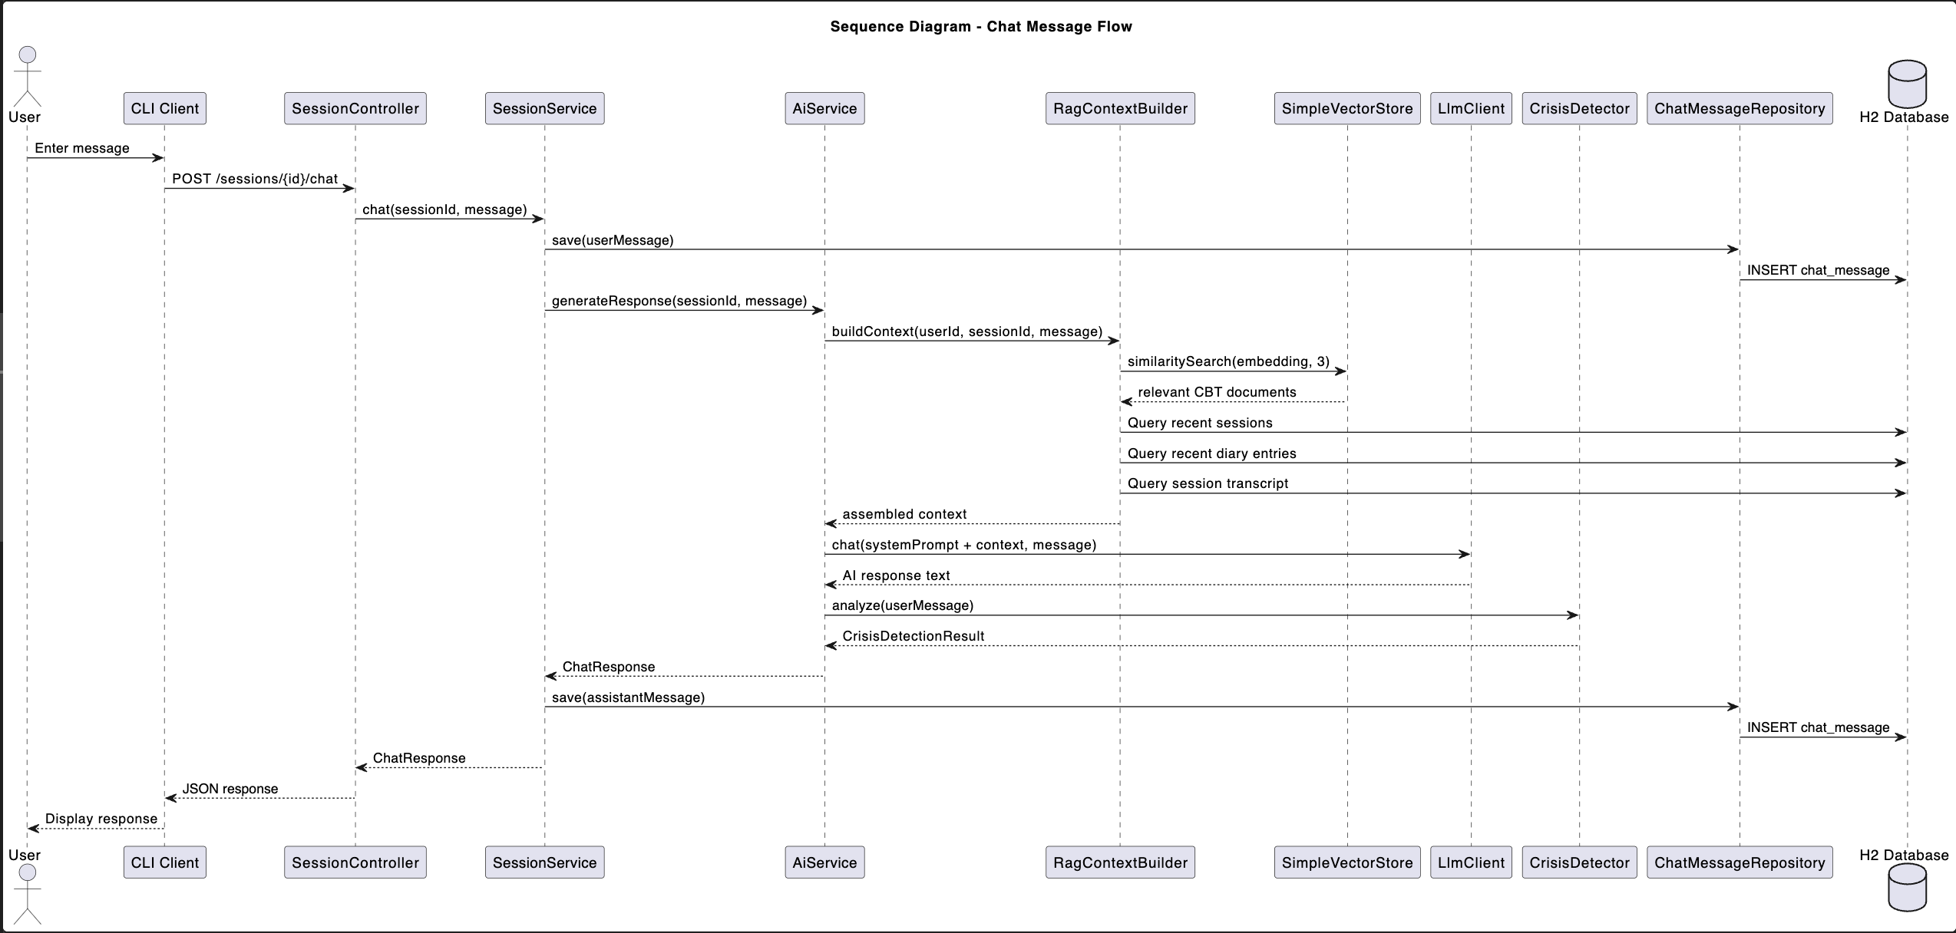

ER Diagram
ER Diagram describing System Data Storage

Deployment Diagram
Deployment Diagram describing System Deployment
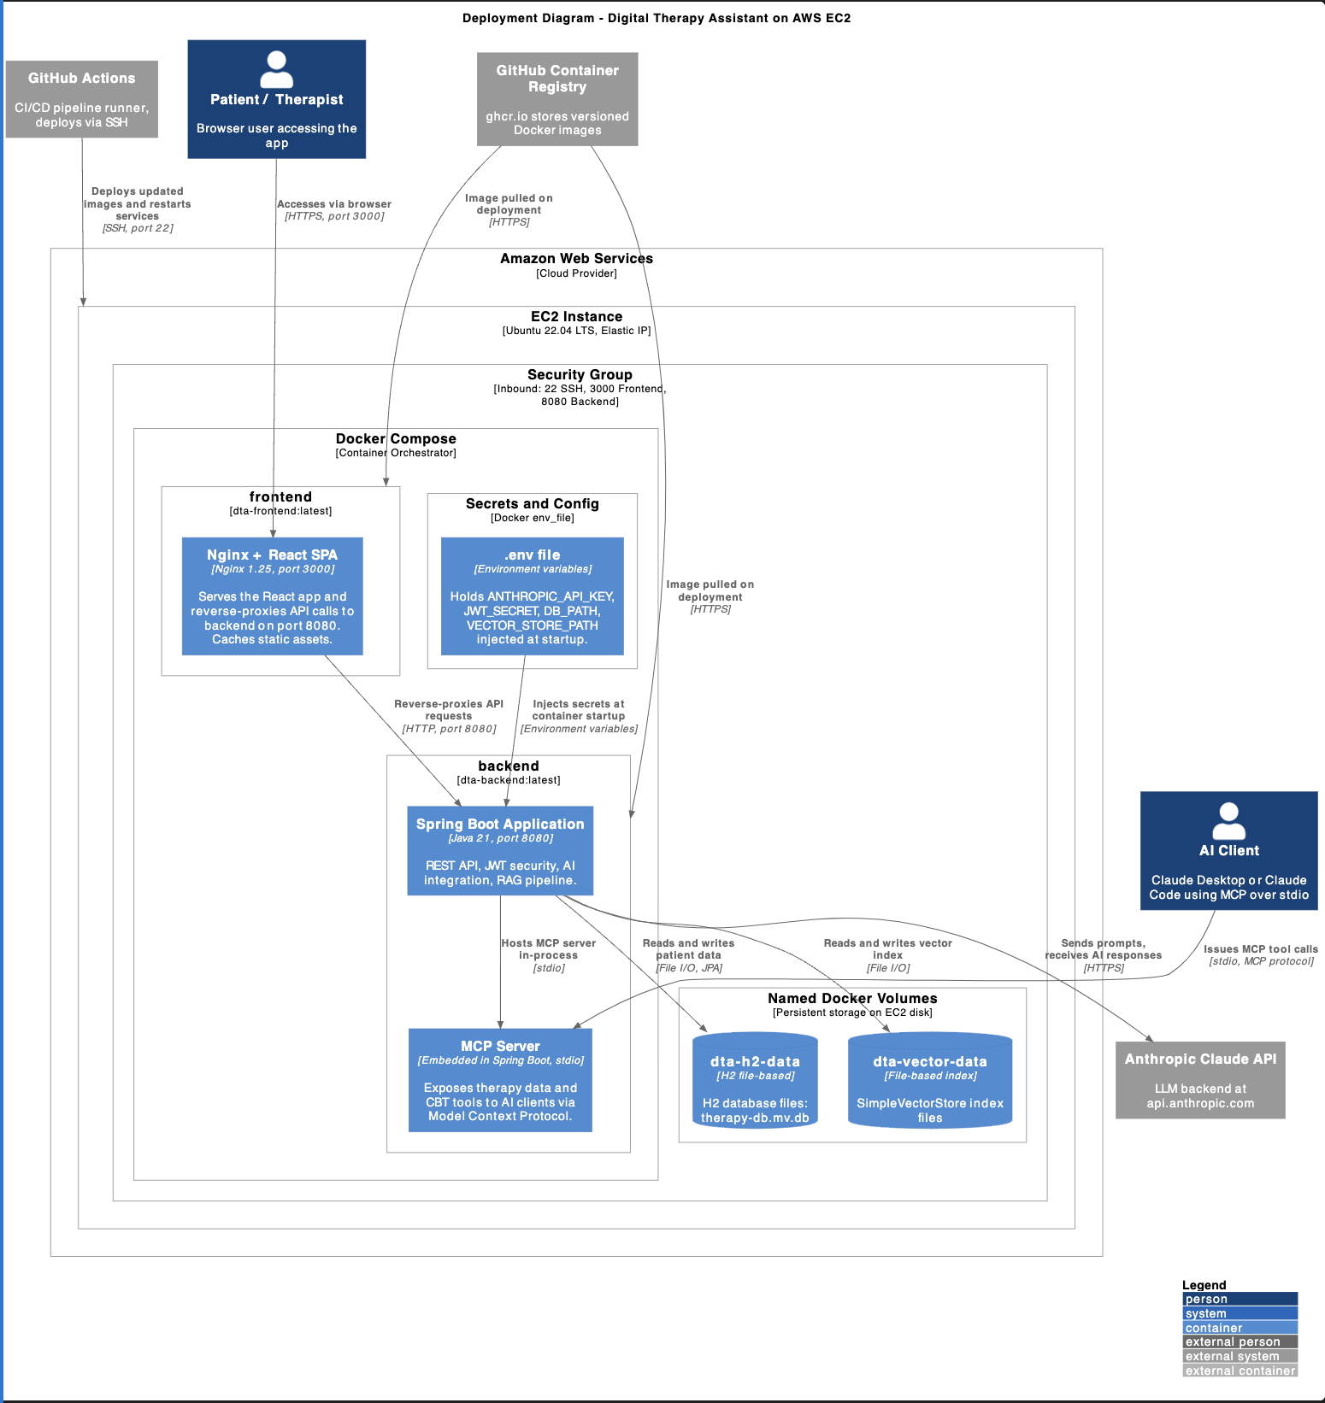

Contextual Contracts
Model Content Protocol tabel describing Tools, Prompts and Resources

MCP Tools
 | Tool Name | Description | Input  Parameters | Return Type | Service  Delegation
1 | start_session | Start a new CBT session for a user | userId: string, sessionId: string | ActiveSession | SessionService
2 | chat_in_session | Send a message in an active CBT session and receive an AI therapeutic response | sessionId: string, message: string | ChatResponse | AiService
3 | end_session | End an active session and generate a closing summary | sessionId: string, reason: string | SessionSummary | SessionService
4 | get_session_library | List all available CBT session modules for a user | userId: string | List<SessionModuleDto> | SessionService
5 | get_session_history | View a user's past sessions | userId: string | List<SessionHistoryEntry> | SessionService
6 | create_diary_entry | Create a new thought diary entry | userId: string, situation: string, automaticThought: string, emotions: string | DiaryEntryResponse | DiaryService
7 | analyze_thought | Analyze a thought for cognitive distortions with confidence scores | thought: string | List<DistortionSuggestion> | AiService
8 | suggest_reframing | Generate reframing prompts for a thought given identified distortions | thought: string, distortionIds: List<string> | List<string> | AiService
9 | detect_crisis | Analyze text for crisis indicators and return a risk level | text: string | CrisisDetectionResult | AiService
10 | get_weekly_progress | Get a user's weekly progress summary | userId: string | WeeklyProgress | ProgressService
11 | get_insights | Get AI-generated insights derived from a user's diary entries | userId: string | DiaryInsights | DiaryService
12 | get_coping_strategies | Retrieve the full list of available coping strategies | N/A | List<CopingStrategy> | CrisisService

MCP Resources
 | Resource URI | Description | Return Type | Data Source
1 | therapy://sessions/{sessionId} | Full detail for a single CBT session | SessionDetail | SessionService
2 | therapy://diary/{userId} | All diary entry summaries for a user | List<DiaryEntrySummary> | DiaryService
3 | therapy://diary/entry/{entryId} | Full detail for a single diary entry | DiaryEntryDetail | DiaryService
4 | therapy://progress/{userId} | Progress overview including trends and burnout metrics | Progress data | ProgressService
5 | therapy://distortions | All cognitive distortion definitions from the knowledge base | List<CognitiveDistortion> | Knowledge Base
6 | therapy://crisis/resources | Emergency resources and crisis contact information | Crisis resource data | CrisisService
7 | therapy://safetyplan/{userId} | A user's personal safety plan | SafetyPlan | CrisisService

MCP Prompts
 | Prompt Name | Description | Arguments | Template Summary
1 | thought_analysis | Structured prompt for analyzing an automatic thought for cognitive distortions | thought: string | Guides the AI to identify distortions, score confidence, and suggest reframing
2 | session_summary | Prompt for generating a therapeutic summary of a completed CBT session | sessionId: string | Produces a structured session recap with insights, progress notes, and next steps
3 | weekly_check_in | Guided weekly check-in template covering mood, progress, and goal review | userId: string | Generates a structured interview-style check-in prompt for the AI to conduct with the user

